**EDGE DETECTION**

1. **Robert**

x = imread('bfly.jpg');

subplot(2,3,1);

imshow(x,[]);

title('Original')

x = double(rgb2gray(x));

x = padarray(x, [1,1], 0, 'post');

subplot(2,3,2);

imshow(x,[]);

title('Grayscale (after padding)')

edgedetection = x;

[m,n] = size(x);

a = [1,0; 0,-1];

for i = 1:m-1

for j = 1:n-1

b = [x(i,j)*a(1,1) x(i+1,j)*a(2,1) x(i,j+1)*a(1,2) x(i+1,j+1)*a(2,2)];

edgedetection(i,j) = sum(b);

end

end

subplot(2,3,4);

edgedetection = uint8(edgedetection);

imshow(edgedetection);

title('Robert(x)');

a = [0,1; -1,0];

for i = 1:m-1

for j = 1:n-1

b = [x(i,j)*a(1,1) x(i+1,j)*a(2,1) x(i,j+1)*a(1,2) x(i+1,j+1)*a(2,2)];

edgedetection(i,j) = sum(b);

end

end

subplot(2,3,5);

edgedetection = uint8(edgedetection);

imshow(edgedetection);

title('Robert(y)');

a = [1,1; -1,-1];

for i = 1:m-1

for j = 1:n-1

b = [x(i,j)*a(1,1) x(i+1,j)*a(2,1) x(i,j+1)*a(1,2) x(i+1,j+1)*a(2,2)];

edgedetection(i,j) = sum(b);

end

end

subplot(2,3,6);

edgedetection = uint8(edgedetection);

imshow(edgedetection);

title('Robert');

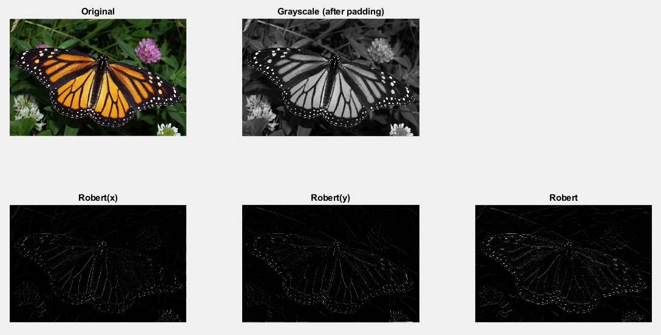

1. **Prewitt**

x = imread('bfly.jpg');

subplot(2,3,1);

imshow(x,[]);

title('Original')

x = double(rgb2gray(x));

x = padarray(x, [1,1], 0, 'both');

subplot(2,3,2);

imshow(x,[]);

title('Grayscale (after padding)')

edgedetection = x;

[m,n] = size(x);

a = [-1,-1,-1; 0,0,0; 1,1,1];

for i = 2:m-1

for j = 2:n-1

b = [x(i-1,j-1)*a(1,1) x(i,j-1)*a(2,1) x(i+1,j-1)*a(3,1) x(i-1,j)*a(1,2) x(i,j)*a(2,2) x(i+1,j)*a(3,2) x(i-1,j+1)*a(1,3) x(i,j+1)*a(2,3) x(i+1,j+1)*a(3,3)];

edgedetection(i,j) = sum(b);

end

end

subplot(2,3,4);

edgedetection = uint8(edgedetection);

imshow(edgedetection);

title('Prewitt(x)');

a = [-1,0,1;-1,0,1;-1,0,1];

for i = 2:m-1

for j = 2:n-1

b = [x(i-1,j-1)*a(1,1) x(i,j-1)*a(2,1) x(i+1,j-1)*a(3,1) x(i-1,j)*a(1,2) x(i,j)*a(2,2) x(i+1,j)*a(3,2) x(i-1,j+1)*a(1,3) x(i,j+1)*a(2,3) x(i+1,j+1)*a(3,3)];

edgedetection(i,j) = sum(b);

end

end

subplot(2,3,5);

edgedetection = uint8(edgedetection);

imshow(edgedetection);

title('Prewitt(y)');

a = [-2, -1, 0; -1, 0, 1; 0, 1, 2];

for i = 2:m-1

for j = 2:n-1

b = [x(i-1,j-1)*a(1,1) x(i,j-1)*a(2,1) x(i+1,j-1)*a(3,1) x(i-1,j)*a(1,2) x(i,j)*a(2,2) x(i+1,j)*a(3,2) x(i-1,j+1)*a(1,3) x(i,j+1)*a(2,3) x(i+1,j+1)*a(3,3)];

edgedetection(i,j) = sum(b);

end

end

subplot(2,3,6);

edgedetection = uint8(edgedetection);

imshow(edgedetection);

title('Prewitt');

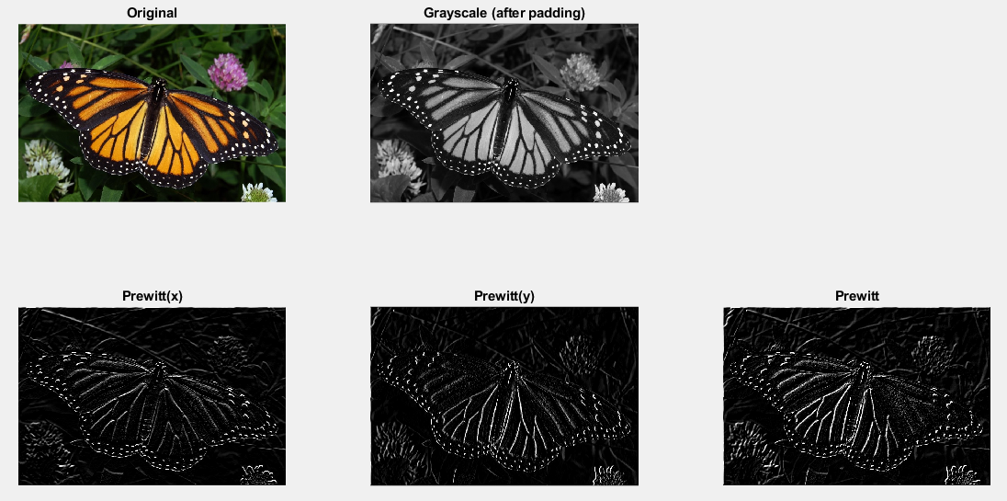

1. **Sobel**

x = imread('bfly.jpg');

subplot(2,3,1);

imshow(x,[]);

title('Original')

x = double(rgb2gray(x));

x = padarray(x, [1,1], 0, 'both');

subplot(2,3,2);

imshow(x,[]);

title('Grayscale (after padding)')

edgedetection = x;

[m,n] = size(x);

a = [-1,-2,-1; 0,0,0; 1,2,1];

for i = 2:m-1

for j = 2:n-1

b = [x(i-1,j-1)*a(1,1) x(i,j-1)*a(2,1) x(i+1,j-1)*a(3,1) x(i-1,j)*a(1,2) x(i,j)*a(2,2) x(i+1,j)*a(3,2) x(i-1,j+1)*a(1,3) x(i,j+1)*a(2,3) x(i+1,j+1)*a(3,3)];

edgedetection(i,j) = sum(b);

end

end

subplot(2,3,4);

edgedetection = uint8(edgedetection);

imshow(edgedetection);

title('Sobel(x)');

a = [-1,0,1;-2,0,2;-1,0,1];

for i = 2:m-1

for j = 2:n-1

b = [x(i-1,j-1)*a(1,1) x(i,j-1)*a(2,1) x(i+1,j-1)*a(3,1) x(i-1,j)*a(1,2) x(i,j)*a(2,2) x(i+1,j)*a(3,2) x(i-1,j+1)*a(1,3) x(i,j+1)*a(2,3) x(i+1,j+1)*a(3,3)];

edgedetection(i,j) = sum(b);

end

end

subplot(2,3,5);

edgedetection = uint8(edgedetection);

imshow(edgedetection);

title('Sobel(y)');

a = [-2, -2, 0; -2, 0, 2; 0, 2, 2];

for i = 2:m-1

for j = 2:n-1

b = [x(i-1,j-1)*a(1,1) x(i,j-1)*a(2,1) x(i+1,j-1)*a(3,1) x(i-1,j)*a(1,2) x(i,j)*a(2,2) x(i+1,j)*a(3,2) x(i-1,j+1)*a(1,3) x(i,j+1)*a(2,3) x(i+1,j+1)*a(3,3)];

edgedetection(i,j) = sum(b);

end

end

subplot(2,3,6);

edgedetection = uint8(edgedetection);

imshow(edgedetection);

title('Sobel');

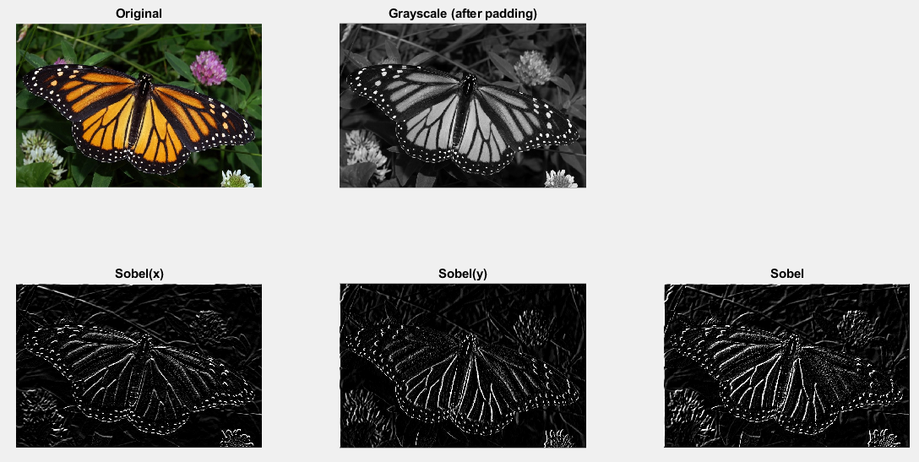

1. **Laplacian**

x = imread('bfly.jpg');

subplot(1,3,1);

imshow(x,[]);

title('Original')

x = double(rgb2gray(x));

x = padarray(x, [1,1], 0, 'both');

subplot(1,3,2);

imshow(x,[]);

title('Grayscale (after padding)')

edgedetection = x;

[m,n] = size(x);

a = [0,-1,0; -1,4,-1; 0,-1,0];

for i = 2:m-1

for j = 2:n-1

b = [x(i-1,j-1)*a(1,1) x(i,j-1)*a(2,1) x(i+1,j-1)*a(3,1) x(i-1,j)*a(1,2) x(i,j)*a(2,2) x(i+1,j)*a(3,2) x(i-1,j+1)*a(1,3) x(i,j+1)*a(2,3) x(i+1,j+1)*a(3,3)];

edgedetection(i,j) = sum(b);

end

end

subplot(1,3,3);

edgedetection = uint8(edgedetection);

imshow(edgedetection);

title('Laplacian');

